Planning a session: Eight session steps
Facilitators can use the following eight steps to plan a session for adolescents, adapting each step to your specific context and program. Eight steps may sound like a lot to include in one or two hours, but some steps take just a few minutes, while others – especially the Challenge step, which is the main activity of any session – take up most of the session time.
Each of the steps serves an important purpose for the Adolescent Circle. As you start to plan sessions, understand how each step might work and how it might be helpful.
Prepare to adapt the steps to adolescents’ interests and contexts, especially with respect to timing. As noted above, for adolescents in the ‘Starting our Circle’ and ‘Knowing Ourselves’ phases, shorter steps may be more appropriate; whereas adolescents in the ‘Connecting’ and ‘Take Action’ phases may want more time for the last few steps. Be flexible – follow the routine created by the steps, but do not stick to it rigidly, if doing so makes activities less interesting or more limiting for adolescents. If you will not be including all eight steps, consider how you can achieve the same goals with different processes.

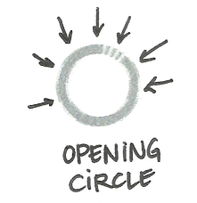 1. Opening Circle
The Opening Circle is practiced at the beginning of each session and makes everyone feel welcome as they start their session together. It should be simple and easy, and give all adolescents in the Circle a chance to participate equally and actively. Opening Circles often involve physical activity to help adolescents feel alert and energized. Some Circles prefer to hold the same Opening Circle at the beginning of every session to provide a sense of ritual and predictability.
Timeframe: 5 minutes (more if the adolescents want it to take longer)
Examples:
- a song
- a chant
- a dance
- a name game
- an exercise routine
- anything else fun, simple, energizing and welcoming.

2. Remind and Refresh
During the Remind and Refresh step, adolescents review what they learned in the previous session. This includes discussing what activities they did in the previous session.
Timeframe: 5 to 10 minutes, depending on whether a thorough review and update is necessary
Examples:
- Adolescents share memories from the last session, including enjoyable moments, special achievements of adolescents in the Circle, or important things they learned.
- One adolescent can role-play the character of a ‘reporter,’ interviewing adolescents about what they remember or learned in the last session.
- Adolescent Circles working together on long-term projects (such the Taking Action cycle) review any progress they have made in their last sessions, and update Circle members who have missed sessions.

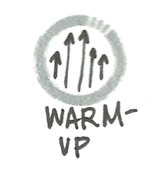3. Warm-Up
The Warm-Up is a short activity at the start of the session. The warm-up activity should engage participants in either energetic or quiet activities. The warm-up should be simple and easy for participants to follow.
Timeframe: 10-15 minutes
Examples:
- Energizers – short, simple games - can be used in the warm-up step to bring participants together in a fun and engaging way. See the Energizers in the Activity Box for ideas!

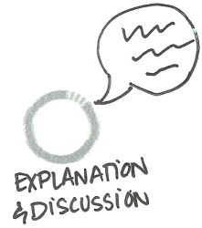4. Explanation and Discussion
The Explanation and Discussion step is a moment of transition between the Warm-Up and the Challenge steps. Adolescents discuss what they experienced and learned during the Warm-Up, and the facilitator explains what the adolescents will do during the Challenge step, which is the main activity of each session.
The Explanation and Discussion step involves more talking than action.It should be adapted to adolescents’ interests and attention spans. Do not push adolescents to sit, talk and listen for a long time, especially if this will stifle their energy after the Warm-Up activity. Give adolescents enough time to understand what they will be doing during the Challenge step, and a chance to ask questions if they need more clarification.
Timeframe: 5-10 minutes
Examples:
Summarize what was learned in the Warm-Up activity then provide instructions for the Challenge activity. (Most Activity Cards begin with these instructions).
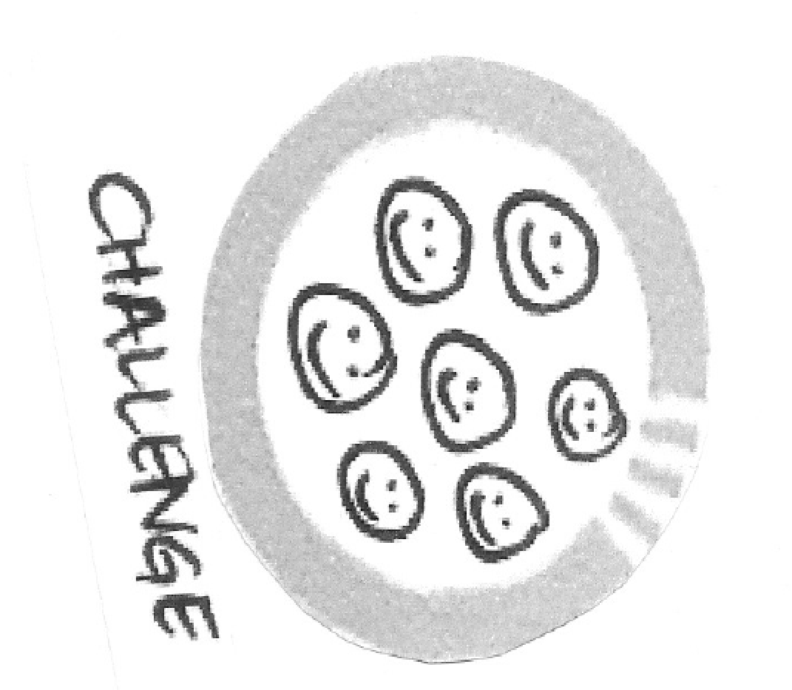5. Challenge
The Challenge step is the main activity of each session. It usually takes up the majority of adolescents’ time in any session.
The Challenge step can be a simple activity that adolescents carry out and complete during one session. The Challenge step can be used to practice a skill they learned in a previous session, or to continue an individual or group project that they work on over the course of several sessions. For those that are in the ‘Starting our Circle’ and ‘Knowing Ourselves’ phases, the Challenge step might be different every day. Adolescents in the ‘Knowing Ourselves’ cycle might use the Challenge step to work on drawings, collages, or other individual projects they started in an earlier session. Adolescents working on group projects in the ‘Taking Action cycle’ can use the Challenge step to plan and work together.
Timeframe: 20 – 60 minutes, or longer
Examples:
- The Activity Box provides 50 activities that can be used for the Challenge step in sessions for adolescents in the four activity phases.
- For adolescents in the ‘Starting our Circle’ phase, the Energizer Cards also give ideas for simple, fun activities for this step.
- Facilitators and adolescents who are ready for a new kind of challenge can also use the Inspiration Cards for ideas for activities to try together.
- Facilitators can also adapt or improvise new activities based on all of the guides and cards in the Activity Box, or use the Activity Template to create new ideas.

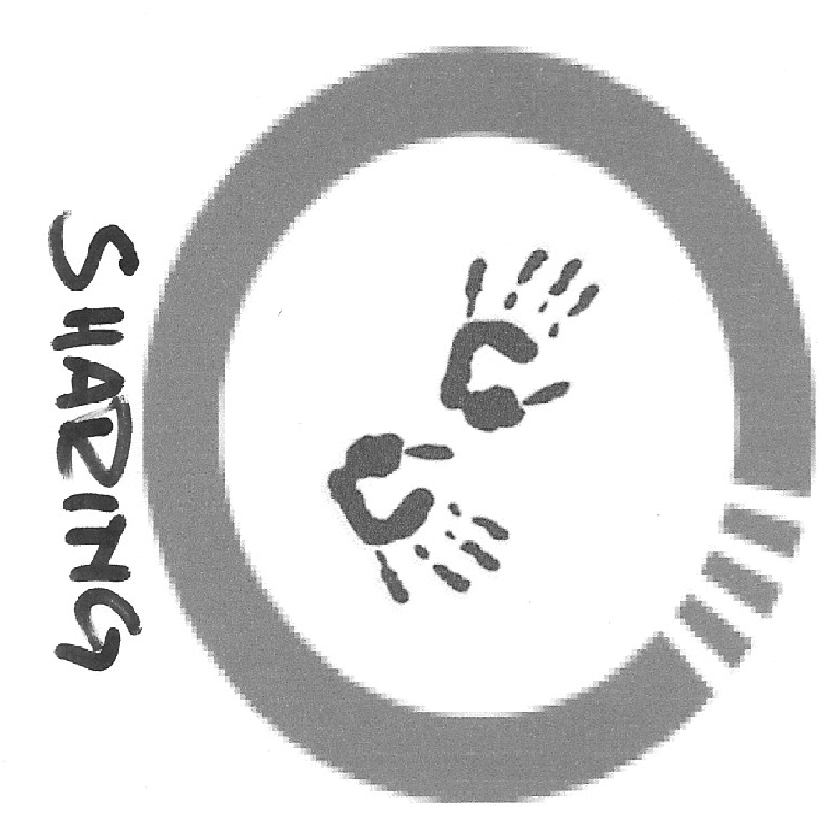6. Sharing and Take Away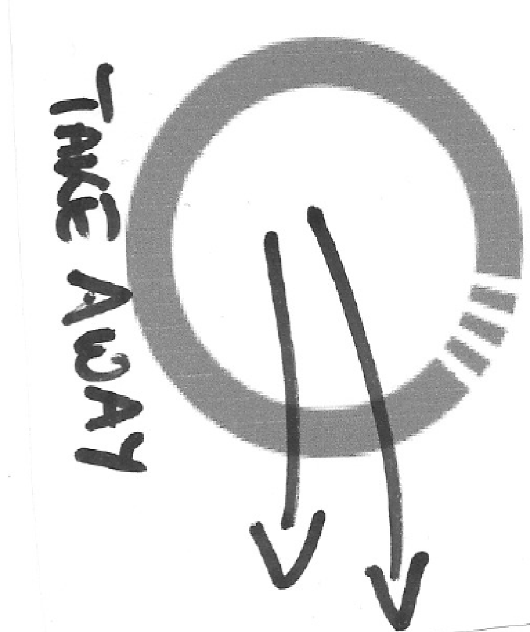
The Sharing and Take Away step is a time for adolescents to share what they have done during the Challenge step with others in their Circle and show, write or draw what they have taken away from their time together.
This step provides facilitators with a valuable chance to assess adolescents’ learning and progress toward their goals. It may be helpful to hold longer, more in-depth Sharing and Take Away discussions or learning assessments every few sessions instead of or in addition to at each session. The Sharing and Take Away step can be connected with the Review step, which can also be helpful for adolescents who have already been working together as a group.
Timeframe: 10-20 minutes, or longer if needed for more in-depth sharing and feedback
Examples:
If adolescents are working on individual projects, they can look at each other’s work and share feedback using the Gallery walk tool. If they have been doing activities in small groups, they can tell each other what they did and compare experiences.
7. Review
During the Review step, adolescents share their feelings and opinions about the whole session. This is a chance for facilitators check whether adolescents are enjoying the sessions, and whether adolescents feel that the sessions are helping to make progress toward their goals.
As with the Sharing and Take Away step, some Circles may want to take extra time for a more in-depth review process every few sessions, instead of or in addition to including it as a step in each session. The Reviewing progress toward group goals activity can be useful for this. The Reviewing group rules activity also helps adolescents to discuss what they can do to make sessions more fun and rewarding.
Timeframe: 5 minutes, unless adolescents want more time

Examples:
- Ask adolescents to show how much did or did not enjoy a session by standing on a real or imaginary line that reaches from one end of the space to the other. One end of the line should represent ‘100% enjoyment’ and the other should represent ‘0% enjoyment.’
- Ask adolescents to share a one word description of how a session made them feel, either verbally or in writing.
- Adolescents can use the Emotion Cube to show how they feel at the end of the session.
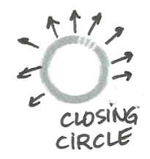
8. Closing Circle
The Closing Circle is practiced at the end of every session. It brings adolescents together to close their time together. It reminds all of the adolescents that they are equal and important members of the Circle, and that their participation in the day’s session was important.
A closing ritual can be a song, a chant, a dance, a game, an exercise routine, or anything else fun, energizing and welcoming. It should be the same every day. Adolescents can invent their own closing circle ritual, and change it whenever they want. Some adolescents may prefer to have the same activity for both the Opening and Closing Circle.
Timeframe: 5 minutes
Example:
Adolescents create a closing circle song and sing it at the end of every session.

Step-by-step: Planning sessions for different Activity Phases
The section provides step-by-step guides for facilitators to plan sessions for adolescents in each of the four Activity Phases. (See the Planning Activity Phases section of the guidance.) Use these guides to developing session plans that will work well for adolescents with different needs, capabilities and interests. Choose and use the guide that is appropriate for the Adolescent Circle with which you are working.

